**Functionality testing**



Header need further development, it’s too simple.



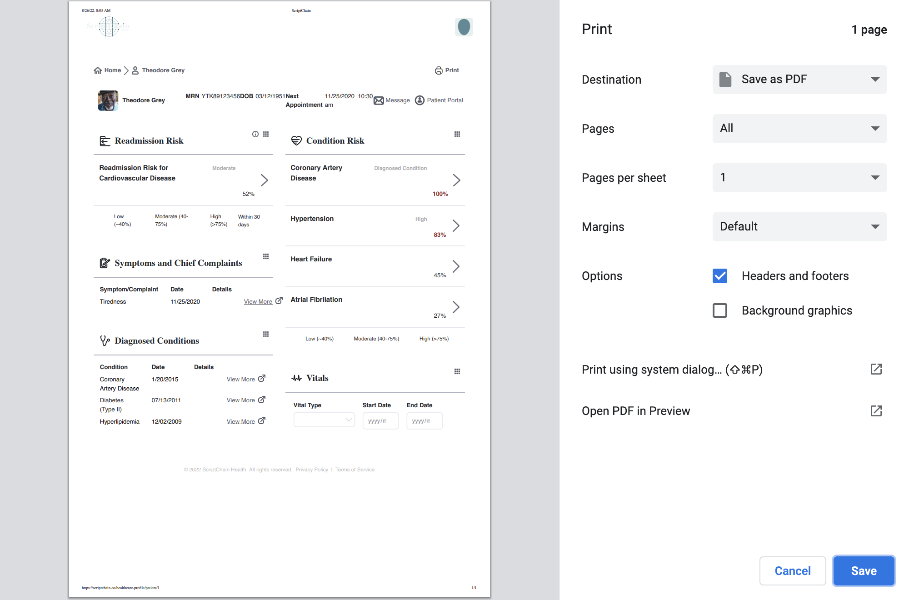

Can’t print progress bar for now.



Small icons are not functional for now.



These two buttons are not functional for now.



View more buttons are not functional for now.

### **Usability Testing ✅**

### **Interface Testing ✅**

### **Compatibility Testing ✅**

### **Performance Testing (need to be done)**

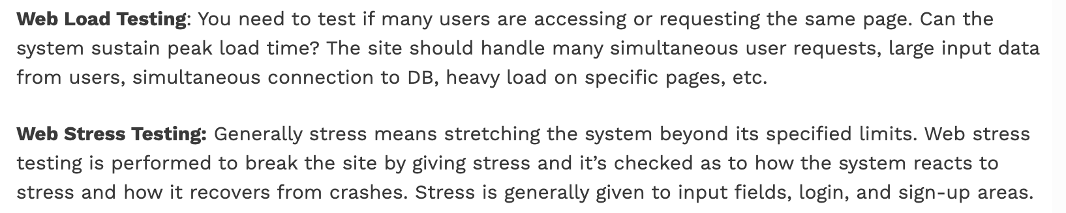

### **Security Testing**

* Test by pasting the internal URL directly into the browser address bar without login. Internal pages should not open. (**login is not ready yet**)
* If you are logged in using a username and password and browsing internal pages, then try changing URL options directly. I.e. If you are checking some publisher site statistics with publisher site ID= 123. Try directly changing the URL site ID parameter to a different site ID that is not related to the logged-in user. Access should be denied for this user to view other people’s stats. (**login is not ready yet**)
* Try some invalid inputs in input fields like login username, password, input text boxes, etc. Check the system’s reaction to all invalid inputs.✅
* Web directories and files should not be accessible directly unless they are given the download option.✅
* Test the CAPTCHA to automate script logins.
* Test if SSL is used for security measures. If used, the proper message should get displayed when users switch from non-secure HTTP:// pages to secure HTTPS:// pages acd vice versa. ✅
* All transactions, error messages, and security breach attempts should be logged in log files somewhere on the webserver. （to be done for all the pages）

**Frontend Testing (**[**Link**](https://www.lambdatest.com/?utm_source=STH&utm_medium=Listing&utm_campaign=Web-App-Testing-Tutorial&utm_term=)**)**

* We use Lambda Testing to test our front-end for functionality and design. In different devices and web applications, the website can look different so it is a great idea to test it on different devices.
* Try different companies to make sure you are building a website that is consistent through all devices, try ios, android, webs etc.
* Different web applications, safari, chrome, firefox, and more can change your design.
* Try different versions of applications as well, different versions of ios, android can change the way it looks as well.
* It is a good idea to check the screen width and height of the devices as well.
* When you start the testing, try using the website like someone who has no idea what they are doing, that way it can create bugs and issues which can be fixed later on.

**Possible problems**

1. Webpages don’t load (some android pages don’t load)
2. Icons look different
3. Different mobiles, such as Ios,Android (Tablets or Mobile), Websites (different web applications such as Safari, Opera, Chrome, Firefox) can lead to different view of the webpage.
4. Components don’t work/Don't work as supposed to (While doing cross browser testing)